Traveling Salesman Problem (TSP)

Aim

To find the shortest possible route that visits each city exactly once and returns to the starting city using Python.

Objectives

Understand the Traveling Salesman Problem.

Find the minimum-cost tour.

Visit every city exactly once.

Return to the starting city.

---

Algorithm

1. Define the distance matrix between cities.

2. Generate all possible city tours.

3. Calculate the total distance for each tour.

4. Compare all tour distances.

5. Select the tour with the minimum distance.

6. Display the shortest path and its cost.

---

Pseudocode

START
Read distance matrix
Generate all possible tours
For each tour
Calculate total distance
If distance is minimum
Store tour
Display shortest tour and distance
STOP

---

Python Code

from itertools import permutations

graph = [
[0, 10, 15, 20],
[10, 0, 35, 25],
[15, 35, 0, 30],
[20, 25, 30, 0]
]

cities = [0, 1, 2, 3]
min_cost = float('inf')
best_path = None

for path in permutations(cities[1:]):
tour = (0,) + path
cost = 0

for i in range(len(tour)-1):
cost += graph[tour[i]][tour[i+1]]

cost += graph[tour[-1]][0]

if cost < min_cost:
min_cost = cost
best_path = tour

print("Shortest Path:", best_path + (0,))
print("Minimum Cost:", min_cost)

---

Result

The shortest tour and its minimum travel cost were found successfully.

---

Sample Output
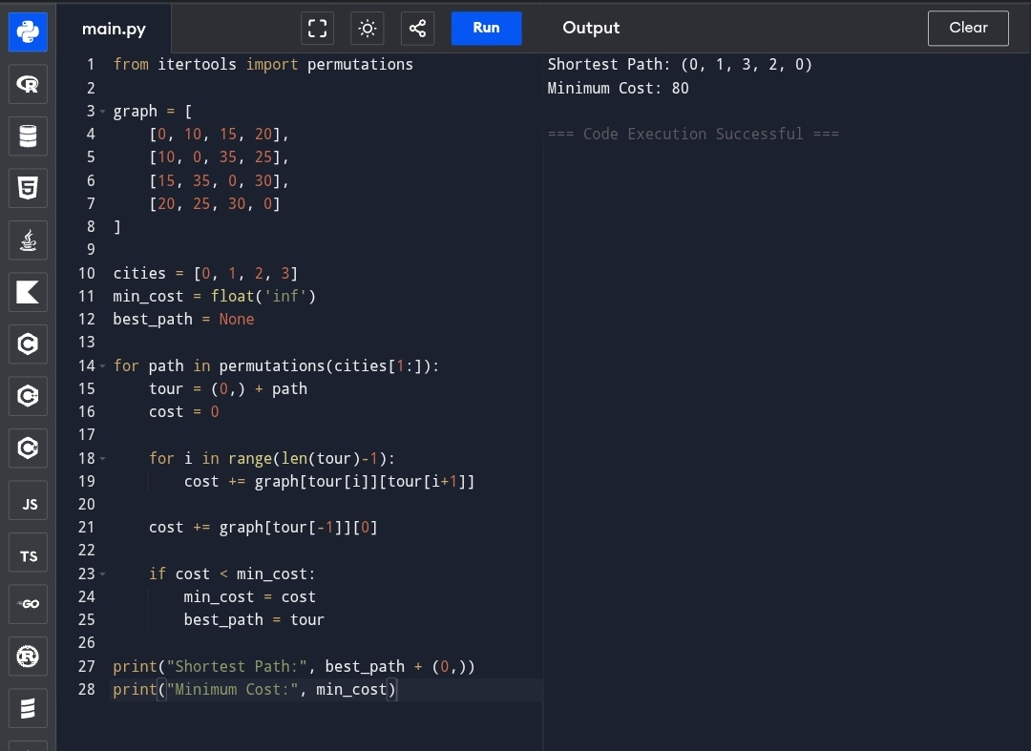

Shortest Path: (0, 1, 3, 2, 0)
Minimum Cost: 80

---

Flowchart

┌──────────┐
│ START │
└────┬─────┘
│
▼
┌─────────────────┐
│ Input Distance │
│ Matrix │
└──────┬──────────┘
│
▼
┌─────────────────┐
│ Generate All │
│ Possible Tours │
└──────┬──────────┘
│
▼
┌─────────────────┐
│ Calculate Tour │
│ Cost │
└──────┬──────────┘
│
▼
┌─────────────────┐
│ Is Cost Minimum?│
└───┬─────────┬───┘
│Yes │No
▼ ▼
Store Best Next Tour
│
▼
┌─────────────────┐
│ Display Best │
│ Path & Cost │
└──────┬──────────┘
│
▼
┌──────┐
│ STOP │
└──────┘

